Subject Name: Web Development Introduction

Subject Code: WEDE5020

Student Name: Mamukeli Ndiweni

Student Number: ST10541377

Date: 17 April 2026

Assignment: Web Development Project Part 1:
Proposal 1
Boost Force Mobile Car Wash

TABLE OF CONTENTS
1. Organisation Overview .................................................................. Page 1
- 1.1 Business History and Context
- 1.2 Mission and Vision Statements
- 1.3 Target Audience Analysis
2. Website Goals and Objectives ....................................................... Page 1
- 2.1 Objective 1
- 2.2 Objective 2
- 2.3 Objective 3
- 2.4 Objective 4
3. Proposed Website Features and Functionality ............................... Page 2
- 3.1 Home page
- 3.2 About us page
- 3.3 Services page
- 3.4 Book now button
- 3.5 Contact page
- 3.6 Navigation Menue
4. Design and User Experience ........................................................... Page 2
- 4.1 Aesthetic and Branding (Color)
- 4.2 Typography (Font Choice)
- 4.3 Low-Fidelity Wireframe Concepts
5. Technical Requirements ................................................................. Page 3
- 5.1 Hosting and Domain Infrastructure
- 5.2 Programming Tech Stack
6. Timeline and Milestones (Gantt Chart) ............................................ Page 3
7. Budget Estimate .............................................................................. Page 4
8. References ...................................................................................... Page 4

1. ORGANISATION OVERVIEW

- 1.1 Business History and Context Boost Force Mobile Car Wash is a Cape Town-based startup established in 2026 to disrupt the traditional "queue-based" automotive cleaning industry. As highlighted by Statista (2025), the rise of the South African on-demand economy has created a significant market for services that prioritize consumer time management.

- 1.2 Mission and Vision Statements
Mission: To deliver premium vehicle care with zero time loss for the client.
Vision: To be the premier on-demand detailing partner in the Western Cape.

- 1.3 Target Audience Analysis The primary target includes corporate professionals in office complexes and residents in high-security estates who seek luxury convenience (Nielsen Norman Group, 2025).

- 2. WEBSITE GOALS AND OBJECTIVES.
2.1. Objective 1: Improve Online Booking Convenience.
The website should allow customers to book car wash services quickly and easily from their phones or computers without making phone calls.
KPI 1: Reduce booking completion time to under 2 minutes.
KPI 2: Achieve at least 80% successful online bookings per month.

2.2. Objective 2: Increase Customer Bookings.
The website should help convert visitors into paying customers through a simple and attractive booking system.
KPI 1: Convert 25% of website visitors into active bookings.
KPI 2: Increase monthly bookings by 15% within the first 6 months.

2.3. Objective 3: Strengthen Brand Awareness.
The website should promote Boost Force Mobile Car Wash as a professional and reliable mobile detailing service in Cape Town.
KPI 1: Reach 5,000 monthly website visitors within the first year.
KPI 2: Increase social media traffic to the website by 20%.

2.4. Objective 4: Improve Customer Satisfaction and Communication.
The website should provide customers with clear service information, pricing, contact details, and booking updates.
KPI 1: Achieve at least 90% positive customer feedback ratings.
KPI 2: Respond to all customer inquiries within 24 hours.

3. PROPOSED WEBSITE FEATURES AND FUNCTIONALITY
- 3.1. Homepage
The homepage is the first page visitors will see when accessing the Boost Force Mobile Car Wash website. It contains a clean and modern design that reflects professionalism and convenience. The page includes the company logo, navigation menu, a large heading introducing the business, and a strong call-to-action “Book Now” button to encourage immediate bookings.
The homepage also features a hero image of a vehicle being cleaned to visually communicate the services offered. Below the hero section, service preview cards are displayed to highlight key services such as exterior washing and interior cleaning. The homepage is designed to create a strong first impression and guide users quickly to important sections of the website (Interaction Design Foundation, 2025)..

- 3.2. About us page.
The About Us page provides detailed information about Boost Force Mobile Car Wash and its business background. This page explains how the company was established and its goal of offering convenient mobile car cleaning services in Cape Town.
The page also includes the mission and vision statements of the business to help customers understand the company’s values and long-term goals. Additional information about customer service, professionalism, and commitment to quality can also be included to build trust and credibility with potential clients.

- 3.3. Services page.
The Services page outlines all the cleaning and detailing services offered by the business. Each service includes a short description, pricing information, and possible service packages available to customers.
Services may include:
-Exterior Wash
-Interior Cleaning
-Vacuuming
-Wax and Polish
-Full Vehicle Detailing
-Tire Cleaning
The page may also include service images or icons to improve visual appeal and help customers understand the available options more easily (Adobe, 2025). This section helps customers compare services and choose the package that best suits their needs.

- 3.4. Book Now Button
The booking page is one of the most important features of the website. It allows customers to schedule a mobile car wash service online quickly and conveniently.
The page includes a booking form where customers can:
-Enter their full name
-Provide contact details
-Select the preferred service
-Choose a booking date and time
-Enter their location or address
-Add special instructions if necessary
The “Book Now” button displayed on the homepage links directly to this page. The goal of the booking system is to reduce booking time and improve customer convenience by allowing users to make appointments without phone calls or physical visits (Smashing Magazine, 2025).
- 3.5. Contact page
The Contact page provides important communication details for customers who may want to ask questions or request additional information.
The page includes:
-Business phone number
-Email address
-Social media links
-Operating hours
-Physical service areas or locations
To meet assignment requirements, at least two service locations can be included, such as:
-Cape Town CBD
-Century City
The page may also include a contact form where users can send messages directly through the website. This feature improves communication and customer support.

- 3.6. Navigation Menu
The website includes a simple and user-friendly navigation menu displayed at the top of each page. The menu allows users to move easily between:
-Home
-Services
-About
-Contact
-Booking
This improves website usability and helps users quickly find the information they need (Nielsen Norman Group, 2025).

4. DESIGN AND USER EXPERIENCE

4.1.Colour Scheme.
The proposed colour palette is inspired by cleanliness, water, professionalism, and modern technology (Adobe, 2025). The colors create a fresh and trustworthy appearance that matches the mobile car wash industry.

Primary Colours
Colour | Purpose | Hex Code
Teal Blue | Main branding colour used for buttons, headings, and highlights | #1FBFCF
Dark Slate Blue | Used for headings, navigation menu, and text | #264653
White | Background colour for a clean and minimal design | #FFFFFF

Secondary Colours
Colour | Purpose | Hex Code
Light Grey | Section backgrounds and borders | #F5F5F5
Soft Cyan | Hover effects and subtle design accents | #A8E6EF

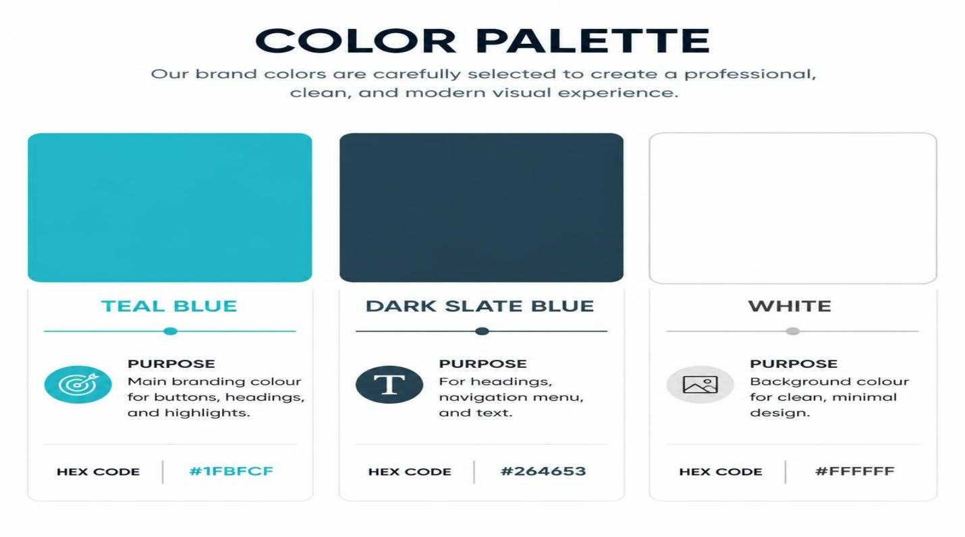

Reasons for the Colour Choice
- Teal Blue represents water, cleanliness, freshness, and professionalism, making it suitable for a car wash brand.
- Dark Slate Blue creates strong contrast for readability and gives the website a premium and trustworthy appearance.
- White backgrounds improve simplicity, cleanliness, and user focus.
- Light Grey and Soft Cyan add balance and modern visual appeal without making the design overcrowded.

4.2.Font Choice.

The website uses simple and modern sans-serif fonts because they are easy to read on both desktop and mobile devices (Webflow, 2025).
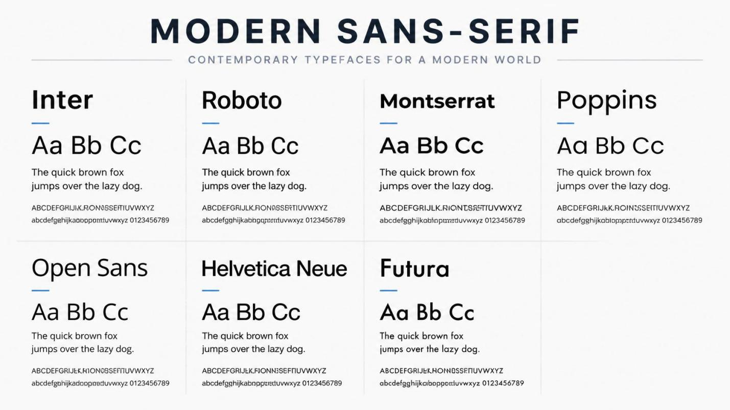
Font | Usage | Reason
Poppins | Main headings and titles | Modern, bold, and professional appearance
Open Sans | Body text and paragraphs | Easy to read and clean for long text
Montserrat | Navigation menu and buttons | Stylish and highly readable

Typography Hierarchy

Heading 1 (H1)
- Used for the main page titles such as “Boost Force”
- Largest font size on the page
- Bold and attention-grabbing
Example:
Boost Force
Professional Mobile Car Wash

Heading 2 (H2)
- Used for section titles such as “Services” or “About Us”
- Slightly smaller than H1 but still noticeable
- Helps divide website sections clearly

Heading 3 (H3)
- Used for smaller headings such as service names:
  - Exterior Wash
  - Interior Cleaning
  - Full Detailing
- Medium-sized font for organization and readability

Body Text
- Used for descriptions, paragraphs, and service information
- Smaller and simple font style for easy reading
- Consistent spacing improves readability and enhances user experience (Interaction Design Foundation, 2025).

Button Text
- Bold and clear typography used for buttons such as:
  - “Book Now”
  - “Contact Us”
- Designed to attract attention and encourage user interaction
The chosen fonts and hierarchy help create a clean user experience that matches the professional image of Boost Force Mobile Car Wash.

- 4.3. Wire Frame
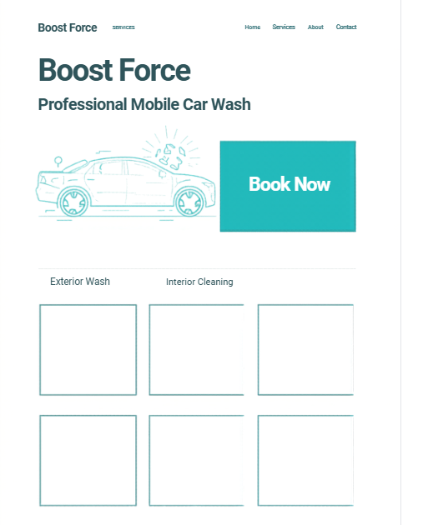
- 4.4. Site Map

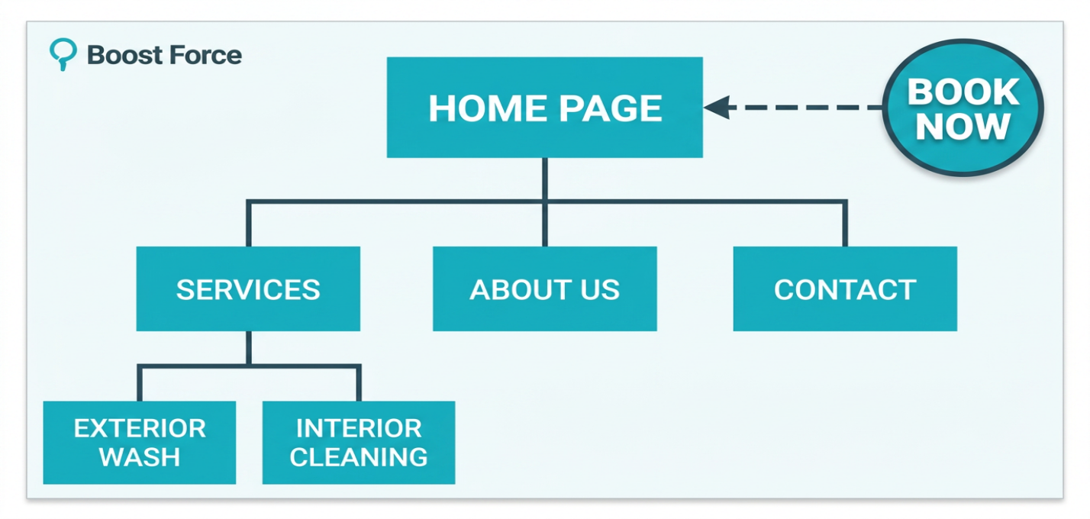

5. TECHNICAL REQUIREMENTS
- 5.1 Hosting and Domain Infrastructure To ensure low latency, the site will use a .co.za domain hosted on local South African servers through Xneelo (Xneelo, 2026).
- 5.2 Programming Tech Stack The platform will be built using semantic HTML5, CSS Grid/Flexbox, and JavaScript for form validation (MDN Web Docs, 2025).
- Responsive web design Will ensure the website functions correctly on desktops, tablets, and mobile devices (Smashing Magazine, 2025).
6. PROJECT TIMELINE
Phase | Task | Mar 15 | Mar 28 | Apr 05 | Apr 15 | Apr 20
1 | Initiation | ████
2 | UI Design |  | ████
3 | Development |  |  | ████
4 | Testing |  |  |  | ████
5 | Deployment |  |  |  |  | ████

7. BUDGET (ZAR)
- Domain & Hosting: R239.00 (Setup)
- Development: R0.00 (Student Project)
- Branding/Photos: R1,500.00
- Maintenance: R150.00 (Monthly)

8. REFERENCES
- Interaction Design Foundation. (2025). Visual hierarchy in web design.
Available at: https://www.interaction-design.org/literature/topics/visual-hierarchy
Accessed: April 2026
- Statista. (2025). On-demand economy trends in South Africa.
Available at: https://www.statista.com
(Search: “on-demand economy South Africa”)
Accessed: April 2026
- Xneelo. (2026). Optimizing local servers for mobile businesses.
Available at: https://xneelo.co.za
Accessed: April 2026
- Adobe. (2025). Principles of modern web design. Available at: https://www.adobe.com
Accessed: April 2026.
- MDN Web Docs. (2025). HTML: HyperText Markup Language. Available at: https://developer.mozilla.org/en-US/docs/Web/HTML
Accessed: April 2026.
- MDN Web Docs. (2025). CSS: Cascading Style Sheets. Available at: https://developer.mozilla.org/en-US/docs/Web/CSS
Accessed: April 2026.
- Nielsen Norman Group. (2025). User experience basics. Available at: https://www.nngroup.com
Accessed: April 2026.
- OpenAI. (2026). ChatGPT assistance for web development planning and coding support. Available at: https://openai.com/chatgpt
Accessed: April 2026.
- Smashing Magazine. (2025). Responsive web design best practices. Available at: https://www.smashingmagazine.com
Accessed: April 2026.
- Statista. (2025). On-demand economy trends in South Africa. Available at: https://www.statista.com
(Search: “on-demand economy South Africa”)
Accessed: April 2026.
- W3Schools. (2025). HTML and CSS tutorials. Available at: https://www.w3schools.com
Accessed: April 2026.
- Webflow. (2025). Modern typography in website design. Available at: https://webflow.com/blog/typography-in-web-design
Accessed: April 2026.
- Google Fonts. (2025). Poppins, Open Sans and Montserrat font families. Available at: https://fonts.google.com
Accessed: April 2026.

